ARCHIVED

U05-1368

ABCD

**Elucidation of Structure**

|  |  |
| --- | --- |
|  | Internal Number |
| **BEA 2180 BR** | 05/029 |
|  |  |
|  | Document Number |
|  | U05-1368 |
|  |  |
|  | Date |
|  | 14 Mar 2005 |
|  |  |
|  | Page |
|  | 1 of 11 |
|  |  |

**Proprietary confidential information**

**© 2005 Boehringer Ingelheim International GmbH or one or more of its affiliated companies**

This document may not - in full or in part - be passed on, reproduced, published or otherwise used without prior written permission

The structure of BEA 2180 BR is derived from the route of synthesis, as described in the “Manufacturing Procedure of the Drug Substance”, and from elemental analysis and spectral data (UV, IR, NMR and mass spectra), as described in this document. All experiments were conducted using batch PR4HAE01939-A1 of BEA 2180 BR.

All data are consistent with the assigned chemical structure.

Due to its high purity, this batch was also assigned as reference standard.

**Elemental Analysis**

The elemental analysis values agreed with the calculated values.

**Elemental Analysis Values (%) of BEA 2180 BR**

|  |  |  |  |  |
| --- | --- | --- | --- | --- |
|  | Carbon | Hydrogen | Nitrogen | Bromine |
| Calculated | 62.88 | 6.16 | 3.06 | 17.43 |
| Found | 62.84 | 6.48 | 3.04 | 17.34 |

**Investigational Medicinal Product Documentation**

**BEA 2180 BR – Version 01 (trial 1205.14)**

ARCHIVED

U05-1368

|  |  |  |  |
| --- | --- | --- | --- |
| **Elucidation of Structure** | Internal Number | Page |  |
| 05/029 | 2 of 11 |  |
|  |  |
|  |  |  |  |

Proprietary confidential information © 2005 Boehringer Ingelheim International GmbH or one or more of its affiliated companies

**Ultraviolet Absorption Spectrum**

UV Spectra of solutions of BEA 2180 BR in ethanol and ethanol/NaOH, prepared at a concentration of 0.05 mg/ml, are shown below. The spectra show small absorption maxima at 258 (in ethanol/NaOH only) and 311 nm. The molar absorptivity for the absorption maximum at 258 nm in ethanol/NaOH was calculated to be 2.10 x 103 L cm-1 mol-1. The molar absorptivity for the absorption maximum at 311 nm was calculated to be 3.90 x 102 (in ethanol) and 1.32 x 103 L cm-1 mol-1 (in ethanol/NaOH).

**Ultraviolet Absorption Spectrum of BEA 2180 BR**

|  |  |  |  |  |  |  |  |
| --- | --- | --- | --- | --- | --- | --- | --- |
|  | 1,2 |  |  |  |  |  |  |
|  | 1,0 |  |  |  |  |  |  |
| **Absorption** | 0,8 |  |  | BEA 2180 BR | |  |  |
| 0,4 |  |  |  |  |  |  |
|  | 0,6 |  |  |  |  |  |  |
|  |  |  | AW100265.SP1 - BEA2180BR ETOH | | |  |  |
|  | 0,2 |  | AW100265.SP2 - BEA2180BR ETOH/NaOH | | |  |  |
|  |  |  |  |  |  |  |
|  | 0,0 |  |  |  |  |  |  |
|  | 200 | 300 | 400 | 500 | 600 | 700 |  |

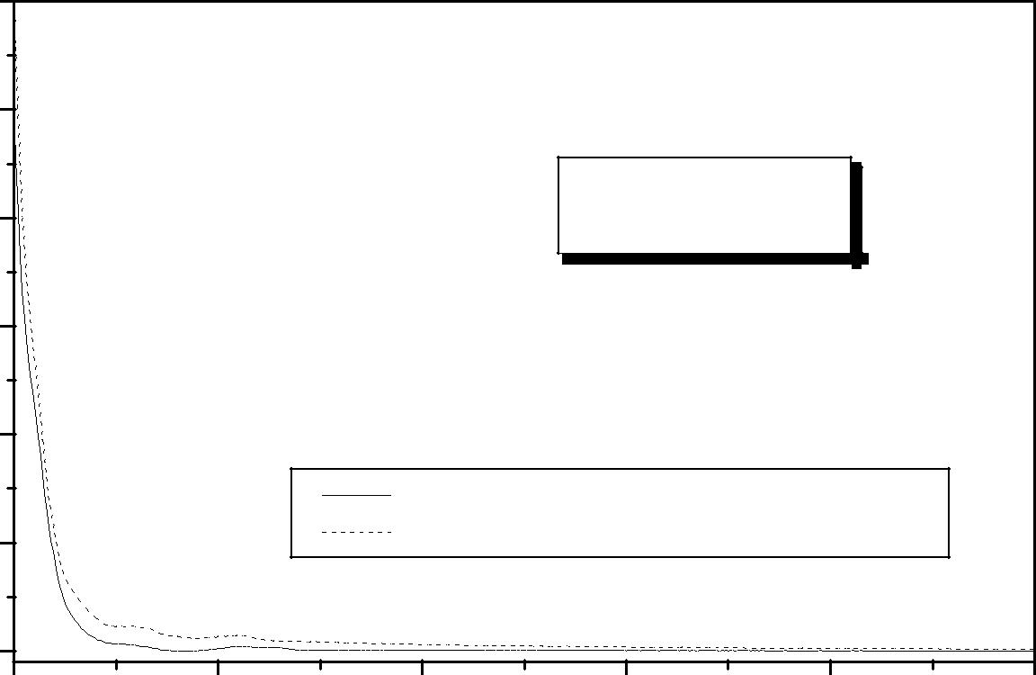

**wavelength [nm]**

**Investigational Medicinal Product Documentation**

**BEA 2180 BR – Version 01 (trial 1205.14)**

ARCHIVED

U05-1368

|  |  |  |  |
| --- | --- | --- | --- |
| **Elucidation of Structure** | Internal Number | Page |  |
| 05/029 | 3 of 11 |  |
|  |  |
|  |  |  |  |

Proprietary confidential information © 2005 Boehringer Ingelheim International GmbH or one or more of its affiliated companies

**Infrared Absorption Spectrum**

The infrared absorption spectrum of BEA 2180 BR, shown below, was acquired using the potassium bromide pellet sampling technique. The major infrared bands and their assignments are summarised in the following table and are consistent with the structure of BEA 2180 BR.

**Infrared Absorption Spectrum of BEA 2180 BR**

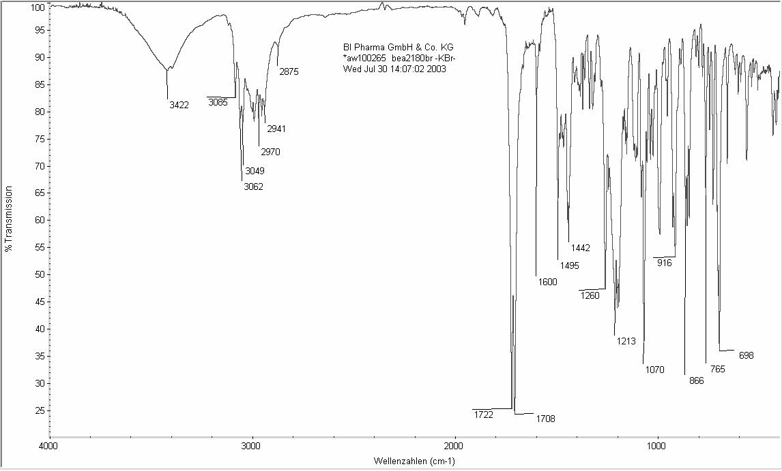

**Investigational Medicinal Product Documentation**

**BEA 2180 BR – Version 01 (trial 1205.14)**

ARCHIVED

U05-1368

|  |  |  |  |
| --- | --- | --- | --- |
| **Elucidation of Structure** | Internal Number | Page |  |
| 05/029 | 4 of 11 |  |
|  |  |
|  |  |  |  |

Proprietary confidential information © 2005 Boehringer Ingelheim International GmbH or one or more of its affiliated companies

**Assignment of Major Infrared Peaks**

|  |  |  |  |  |
| --- | --- | --- | --- | --- |
| **Wave number (cm-1)** | | **Assignment** | **Kind of vibration** |  |
| 3422 | | HO–H | stretching |  |
|  |  |  |  |  |
| 3085, 3062, 3049 | | epoxide C–H | stretching |  |
| aryl C−H |  |
|  |  |  |  |
|  | |  |  |  |
| 2970, 2875 | | −CH3 | asym. + sym. stretching |  |
|  | |  |  |  |
| 2941 | | –CH2 | asym. stretching |  |
|  |  |  |  |  |
| 1722, | 1708 | alkylester C=O | stretching |  |
|  | |  |  |  |
| 1600, 1495, 1442 | | C=C | ring stretching |  |
|  | |  |  |  |
| 1260 | | epoxide C−O | stretching |  |
|  | |  |  |  |
| 1213, 1070 | | ester C−O−C | stretching |  |
|  |  |  |  |  |
| 916, | 866 | epoxide C−O | ring vibrations |  |
|  |  |  |  |  |
| 765, | 698 | 5 adjacent H | wagging and ring deformation |  |
|  |  |  |  |  |

**Investigational Medicinal Product Documentation**

**BEA 2180 BR – Version 01 (trial 1205.14)**

ARCHIVED

U05-1368

|  |  |  |  |
| --- | --- | --- | --- |
| **Elucidation of Structure** | Internal Number | Page |  |
| 05/029 | 5 of 11 |  |
|  |  |
|  |  |  |  |

Proprietary confidential information © 2005 Boehringer Ingelheim International GmbH or one or more of its affiliated companies

**Nuclear Magnetic Resonance (NMR) Spectra**

Analysis of BEA 2180 BR by proton and carbon NMR provided spectra that are consistent with the structure. Analysis of the data led to complete assignment of the proton and carbon signals.

The 1H-NMR spectrum of BEA 2180 BR is shown in the following figure and a summary of the 1H-NMR peak assignments is provided in the following table.

**400 MHz 1H-NMR Spectrum of BEA 2180 BR in DMSO-d6**

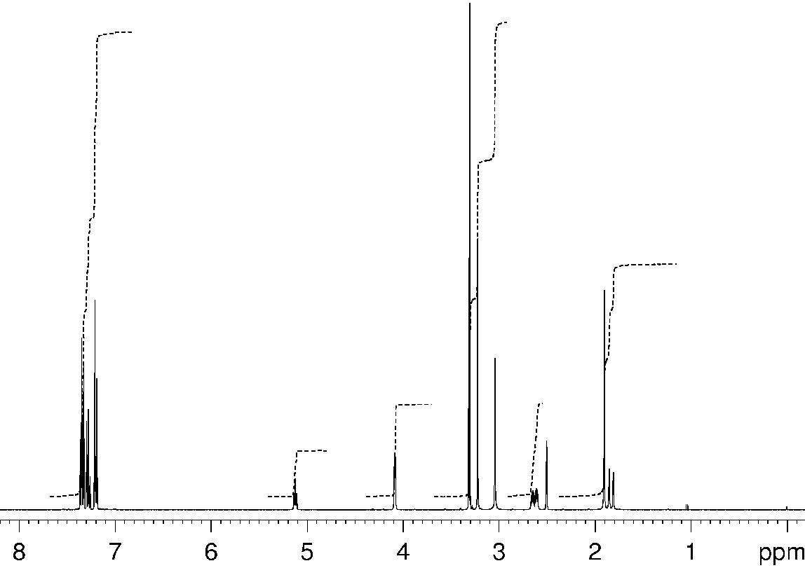

**Investigational Medicinal Product Documentation**

**BEA 2180 BR – Version 01 (trial 1205.14)**

ARCHIVED

U05-1368

|  |  |  |  |
| --- | --- | --- | --- |
| **Elucidation of Structure** | Internal Number | Page |  |
| 05/029 | 6 of 11 |  |
|  |  |
|  |  |  |  |

Proprietary confidential information © 2005 Boehringer Ingelheim International GmbH or one or more of its affiliated companies

**1H-NMR Assignments of BEA 2180 BR in DMSO-d6**

|  |  |  |  |  |  |  |  |  |
| --- | --- | --- | --- | --- | --- | --- | --- | --- |
|  |  | CH |  | 9 |  |  |  |  |
|  |  | 3 | |  |  | Br |  |  |
| 8 H C | N | + |  |  |  |  |  |
| 3 | 5 |  |  | 4 |  |  |  |
|  |  |  |  |  |  |  |
| O | 1 |  |  |  | 2 |  |  |  |
|  | 6 |  |  |  |  |  |
|  |  |  |  | 3 H |  |  |  |
|  | 7 |  |  |  |  | 17 |  |
|  | H |  |  |  |  |  |
|  |  |  |  | O |  |  |
|  | H |  |  | 18 | 16 |  |
|  |  |  |  |  |
|  |  |  |  |  |  |  |  |
|  |  |  |  |  | 11 |  |  |  |
|  |  |  | O | | 12 | 13 | 15 |  |
|  |  |  |  | CH 14 | |  |
|  |  |  |  |  | 19 |  |
|  |  |  |  |  | 25 | 3 |  |
|  |  |  |  |  | 24 | 20 |  |  |
|  |  |  |  |  | 23 | 21 |  |  |
|  |  |  |  |  |  |  |  |
|  |  |  |  |  | 22 |  |  |  |

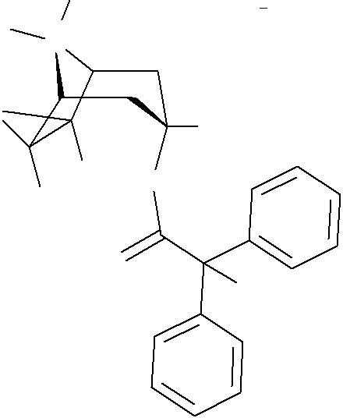

|  |  |  |  |  |  |  |  |  |
| --- | --- | --- | --- | --- | --- | --- | --- | --- |
| **Position** | |  | **Chemical shift δ** | **Multi-** | **J (Hz)** |  | **Inte-** |  |
|  | **(ppm)** | **plicity** |  | **gration** |  |
|  |  |  |  |  |  |  |  |  |
| 1 | , 5 |  | 4.08 | m | Not resolved |  | 2 |  |
| 2 , 4 ax | |  | 2.63 | ddd | J2,2 = 17.6 , J2,1 = 4.3 , J2,3 = 6.1 |  | 2 |  |
| 2 , 4 eq | |  | 1.83 | d | J2ax,2eq = 17.2 |  | 2 |  |
| 3 eq | |  | 5.12 | t | J 2ax,3eq = 6.1 |  | 1 |  |
| 6 | , 7 |  | 3.31 | s |  |  | 2 |  |
|  | 8 |  | 3.22 | s |  |  | 3 |  |
|  | 9 |  | 3.04 | s |  |  | 3 |  |
| 14 | , 18 |  | 7.20 | m |  |  | 2 |  |
| 15 | , 17 |  | 7.35 | m |  |  | 2 |  |
| 16 | |  | 7.28 | m |  |  | 1 |  |
| 20 | , 24 |  | 7.20 | m |  |  | 2 |  |
| 21 | , 23 |  | 7.35 | m |  |  | 2 |  |
| 22 | |  | 7.28 | m |  |  | 1 |  |
| 25 | |  | 1.90 | s |  |  | 3 |  |
| Abbreviations: | | | s = singlet, d = doublet, ddd = double double doublet, t = triplet, m = multiplet | | | |  |  |
|  |  |  | ax = axial, eq = equatorial | |  |  |  |  |

**Investigational Medicinal Product Documentation**

**BEA 2180 BR – Version 01 (trial 1205.14)**

ARCHIVED

U05-1368

|  |  |  |  |
| --- | --- | --- | --- |
| **Elucidation of Structure** | Internal Number | Page |  |
| 05/029 | 7 of 11 |  |
|  |  |
|  |  |  |  |

Proprietary confidential information © 2005 Boehringer Ingelheim International GmbH or one or more of its affiliated companies

The 13 C-NMR spectrum of BEA 2180 BR is shown in the following figure and a summary of the 13C-NMR peak assignments is provided in the following table.

**100 MHz 13C-NMR Spectrum of BEA 2180 BR in DMSO-d6**

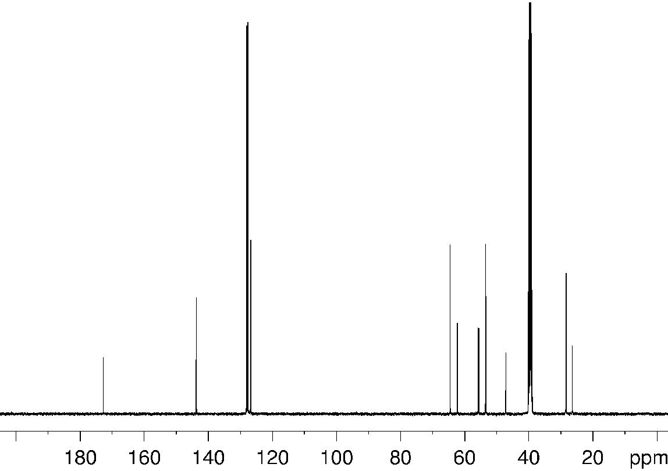

**Investigational Medicinal Product Documentation**

**BEA 2180 BR – Version 01 (trial 1205.14)**

ARCHIVED

U05-1368

|  |  |  |  |
| --- | --- | --- | --- |
| **Elucidation of Structure** | Internal Number | Page |  |
| 05/029 | 8 of 11 |  |
|  |  |
|  |  |  |  |

Proprietary confidential information © 2005 Boehringer Ingelheim International GmbH or one or more of its affiliated companies

**13C-NMR Assignments of BEA 2180 BR in DMSO-d6**

|  |  |  |  |  |  |  |  |  |  |  |  |  |  |  |  |  |  |
| --- | --- | --- | --- | --- | --- | --- | --- | --- | --- | --- | --- | --- | --- | --- | --- | --- | --- |
|  |  |  |  |  | CH |  | 9 |  |  |  |  |  |  |  |  |  |  |
|  |  |  |  |  | 3 | |  |  |  |  |  | Br |  |  |  |  |  |
|  |  | 8 H C | N | | + |  |  |  |  |  |  |  |  |  |  |  |
|  |  | 3 | 5 |  |  | 4 | | |  |  |  |  |  |  |  |
|  |  |  |  |  |  |  |  |  |  |  |  |  |  |
|  |  | O | 1 |  |  |  |  |  |  |  |  |  |  |  |  |  |  |
|  |  |  | 6 |  |  | 2 |  |  | H |  |  |  |  |  |  |
|  |  |  |  |  |  |  |  |  |  |  |  |  |  |
|  |  |  | 7 |  |  |  |  |  |  | 3 |  |  |  | 17 |  |  |
|  |  |  |  | H |  |  |  |  |  |  |  |  |  |  |  |
|  |  |  |  |  |  |  |  | O | | |  |  |  |  |  |
|  |  |  | H | |  |  |  | 18 |  |  | 16 | |  |
|  |  |  |  |  |  |  |  |  |  |
|  |  |  |  |  |  |  |  |  |  |  |  |  |  |  |  |
|  |  |  |  |  |  |  |  | 11 | | |  |  |  |  |  |  |  |
|  |  |  |  |  |  | O | | 12 | | | | 13 |  |  | 15 | |  |
|  |  |  |  |  |  |  |  |  |  | CH | | | 14 |  |  |
|  |  |  |  |  |  |  |  | 19 | | | |  |  |
|  |  |  |  |  |  |  |  | 25 |  |  | 3 |  |  |
|  |  |  |  |  |  |  |  | 24 | |  |  | 20 | |  |  |  |  |
|  |  |  |  |  |  |  |  | 23 | |  |  | 21 | |  |  |  |  |
|  |  |  |  |  |  |  |  |  |  |  |  |  |  |  |  |
|  |  |  |  |  |  |  |  | 22 | | | |  |  |  |  |  |  |
|  |  |  |  | | |  |  |  |  | | | | | | |  |  |
|  | **Position** | **Chemical shift δ** | **(ppm)** | | |  |  |  | **Multiplicity*)** | | | | | | | **Number of carbon atoms+)** |  |
|  | 1 , 5 | 64.4 |  |  |  |  |  |  |  |  | d |  |  |  |  | 2 |  |
|  | 2 , 4 | 28.3 |  |  |  |  |  |  |  |  | t |  |  |  |  | 2 |  |
|  | 3 | 62.2 |  |  |  |  |  |  |  |  | d |  |  |  |  | 1 |  |
|  | 6 , 7 | 53.4 |  |  |  |  |  |  |  |  | d |  |  |  |  | 2 |  |
|  | 8 | 55.5 |  |  |  |  |  |  |  |  | q |  |  |  |  | 1 |  |
|  | 9 | 47.1 |  |  |  |  |  |  |  |  | q |  |  |  |  | 1 |  |
|  | 11 | 172.8 |  |  |  |  |  |  |  |  | s |  |  |  |  | 1 |  |
|  | 12 | 55.8 |  |  |  |  |  |  |  |  | s |  |  |  |  | 1 |  |
|  | 13 | 143.7 |  |  |  |  |  |  |  |  | s |  |  |  |  | 1 |  |
|  | 14 , 18 | 127.7 |  |  |  |  |  |  |  |  | d |  |  |  |  | 2 |  |
|  | 15 , 17 | 128.1 |  |  |  |  |  |  |  |  | d |  |  |  |  | 2 |  |
|  | 16 | 126.7 |  |  |  |  |  |  |  |  | d |  |  |  |  | 1 |  |
|  | 19 | 143.7 |  |  |  |  |  |  |  |  | s |  |  |  |  | 1 |  |
|  | 20 , 24 | 127.7 |  |  |  |  |  |  |  |  | d |  |  |  |  | 2 |  |
|  | 21 , 23 | 128.1 |  |  |  |  |  |  |  |  | d |  |  |  |  | 2 |  |
|  | 22 | 126.7 |  |  |  |  |  |  |  |  | d |  |  |  |  | 1 |  |
|  | 25 | 26.3 |  |  |  |  |  |  |  |  | q |  |  |  |  | 1 |  |
| Abbreviations: | | s = singlet, d = doublet, t = triplet, q = quartet. | | | | | | | | | | | | | | |  |
|  |  | *) The given multiplicities are based on DEPT and HC-HSQC spectra. | | | | | | | | | | | | | | |  |

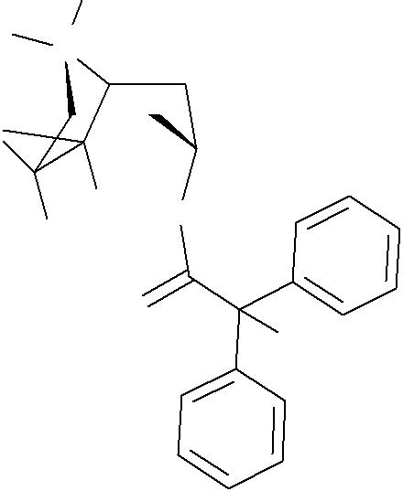

+) The number of carbon atoms was determined by an HC-HSQC spectrum in combination with the integration of the corresponding proton signals.

**Investigational Medicinal Product Documentation**

**BEA 2180 BR – Version 01 (trial 1205.14)**

ARCHIVED

U05-1368

|  |  |  |  |
| --- | --- | --- | --- |
| **Elucidation of Structure** | Internal Number | Page |  |
| 05/029 | 9 of 11 |  |
|  |  |
|  |  |  |  |

Proprietary confidential information © 2005 Boehringer Ingelheim International GmbH or one or more of its affiliated companies

**Mass Spectrum**

The mass spectrum of BEA 2180 BR obtained by electrospray mass spectrometry is shown below. The observed mass (m/z 378.3) is consistent with the molecular mass of the quarternary cation of BEA 2180 BR.

**Mass Spectrum of BEA 2180 BR obtained by Electrospray Mass Spectrometry**

|  |  |  |  |  |
| --- | --- | --- | --- | --- |
| **BEA2180, PR4HAE01939A1 in ACN/H2O** |  | **Quattro LC (9247)** | **22-Aug-2003 11:17:48** |  |
| AW100265_FKA1 20 (1.046) Cn (Cen,7, 80.00, Ht); Sm (SG, 2x0.50); Cm (20:24) | |  | Scan ES+ |  |
| 100 | 378.3 |  | 2.78e7 |  |
|  |  |  |  |

%

379.3



|  |  |  |  |  |  |  |  |  |  |  |  |  |  |  |  |  |  |  |  |  |  |  |
| --- | --- | --- | --- | --- | --- | --- | --- | --- | --- | --- | --- | --- | --- | --- | --- | --- | --- | --- | --- | --- | --- | --- |
|  |  |  |  |  |  |  |  | 380.3 |  |  |  |  |  |  |  |  |  |  |  |  |  |  |
| 0 |  |  |  |  |  |  |  |  |  |  |  |  |  |  |  |  |  |  |  |  | m/z |  |
|  |  |  |  |  |  |  |  |  |  |  |  |  |  |  |  |  |  |  |  |  |
| 50 | | 100 | 150 | 200 | 250 | 300 | 350 | 400 | 450 | 500 | 550 | 600 | 650 | 700 | 750 | 800 | 850 | 900 | 950 | 1000 | |  |



**Investigational Medicinal Product Documentation**

**BEA 2180 BR – Version 01 (trial 1205.14)**

ARCHIVED

U05-1368

|  |  |  |  |
| --- | --- | --- | --- |
| **Elucidation of Structure** | Internal Number | Page |  |
| 05/029 | 10 of 11 |  |
|  |  |
|  |  |  |  |

Proprietary confidential information © 2005 Boehringer Ingelheim International GmbH or one or more of its affiliated companies

The mass spectrum of BEA 2180 BR obtained by electrospray collision induced dissociation mass spectrometry is shown below. The observed fragmentation is consistent with the structure of BEA 2180 BR.

**Mass Spectrum of BEA 2180 BR obtained by Electrospray Collision Induced Dissociation Mass Spectrometry**

|  |  |  |  |  |
| --- | --- | --- | --- | --- |
| **BEA2180, PR4HAE01939A1 in ACN/H2O** |  | **Quattro LC (9247)** | **22-Aug-2003 11:26:17** |  |
| AW100265_FKD1 21 (1.097) Cn (Cen,5, 80.00, Ht); Sm (SG, 2x0.50); Cm (20:29) | |  | Daughters of 378ES+ |  |
| 100 | 152.0 |  | 9.33e6 |  |
|  |  |  |  |

%

|  |  |  |  |  |  |  |  |  |  |  |  |  |  |  |  |  |  |  |  |  |  |  |  |  |  |  |  |  |
| --- | --- | --- | --- | --- | --- | --- | --- | --- | --- | --- | --- | --- | --- | --- | --- | --- | --- | --- | --- | --- | --- | --- | --- | --- | --- | --- | --- | --- |
|  |  |  |  | 84.1 | | |  |  |  |  |  |  |  |  |  |  |  |  |  |  |  |  |  |  | 378.1 | |  |  |
|  |  |  | 81.1 | 94.0 | | |  |  |  |  |  |  |  |  |  |  |  |  |  |  |  |  |  |  |  |
|  |  |  | 79.1 |  |  |  |  |  |  | 122.0 | |  | 153.0 | 181.0 | |  |  |  |  |  |  |  |  |  |  |  |  |  |
| 0 |  |  |  |  |  |  |  |  |  |  |  |  |  |  |  |  |  |  |  |  |  |  |  |  |  |  | m/z |  |
| 40 | | 60 | 80 | | |  | 100 | | | 120 | | 140 | 160 | 180 | | 200 | 220 | 240 | 260 | 280 | 300 | 320 | 340 | 360 | 380 | |  |  |



**Investigational Medicinal Product Documentation**

**BEA 2180 BR – Version 01 (trial 1205.14)**

ARCHIVED

U05-1368

|  |  |  |  |
| --- | --- | --- | --- |
| **Elucidation of Structure** | Internal Number | Page |  |
| 05/029 | 11 of 11 |  |
|  |  |
|  |  |  |  |

Proprietary confidential information © 2005 Boehringer Ingelheim International GmbH or one or more of its affiliated companies

**Interpretation of the Observed Fragmentation Pattern of BEA 2180 BR**

|  |  |  |  |
| --- | --- | --- | --- |
| **Ion mass** | **Rel.** | **Interpretation of the fragment ions** |  |
| **(m/z)** | **intensity** |  |
| CH3 |  |
|  |  |  |
|  | H3C | N+ |  |
|  | O | H |  |
|  |  |  |
| 378.1 | 8 | O |  |
|  |  |
|  |  | O |  |
|  |  | CH3 |  |
|  |  | parent ion, selected for CID |  |
|  |  | CH2+ |  |
| 181.0 | 2 |  |  |
| 152.0 | 100 | N+ |  |
|  |  |
|  |  | O |  |
| 122.0 | 2 | N+ |  |

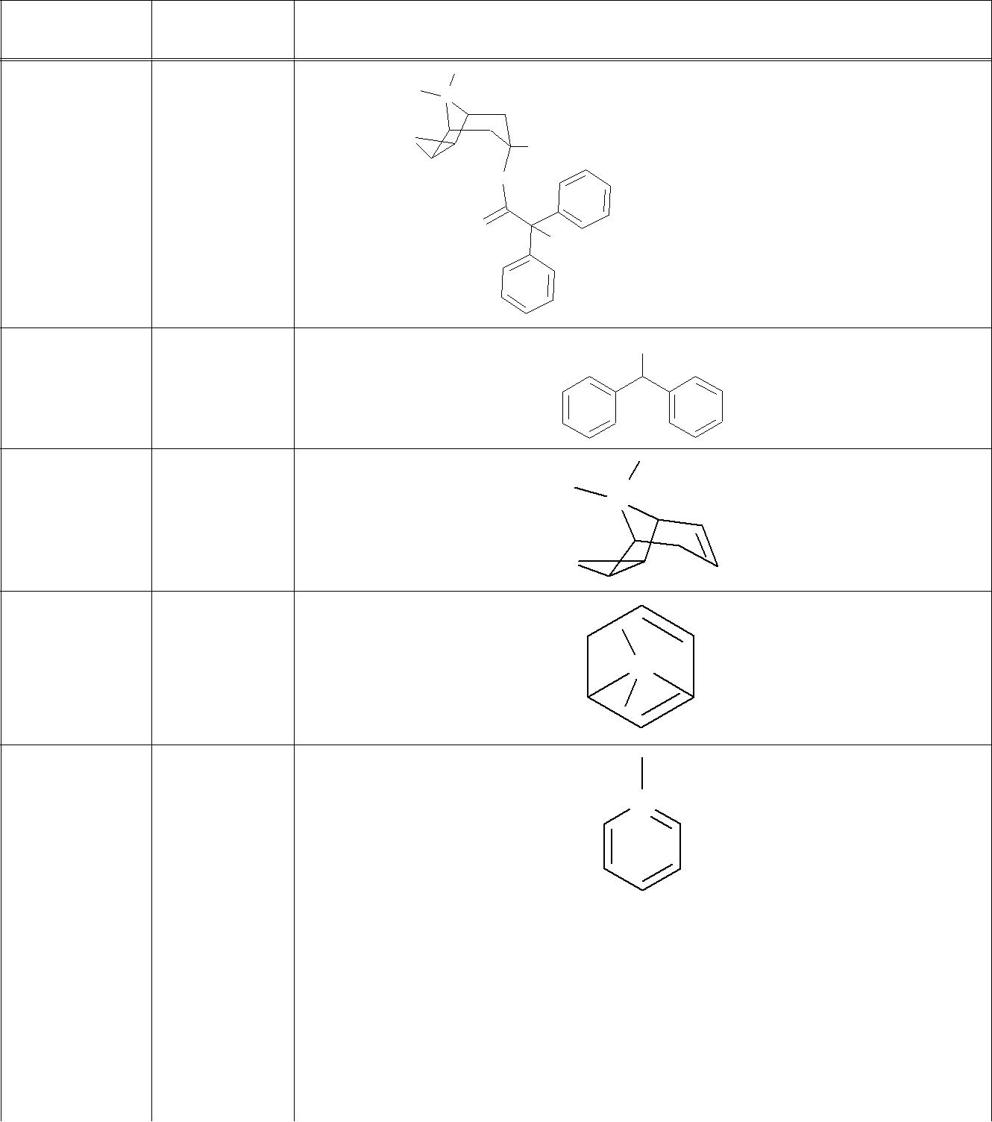

N+

94.0 4

|  |  |  |  |
| --- | --- | --- | --- |
| 91.0 | 3 | CH2+ |  |
| + |  |
| 84.1 | 6 | C5H10N |  |
| 81.1 | 4 | C6H9 |  |
| 79.1 | 1 | C6H7 |  |

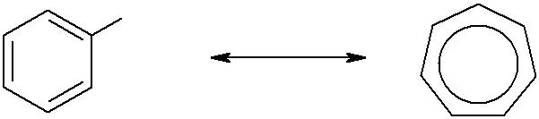

**Investigational Medicinal Product Documentation**

**BEA 2180 BR – Version 01 (trial 1205.14)**